Department of Veterans Affairs
Emergency Department Integration Software (EDIS)
Big Board Installation Guide

VistA EDP*2.0*2
GUI EDIS Version 2.1.2
November 2014
Document Version 1.7
Office of Information and Technology (OI&T)
Product Development
Revision History
Date | Version | Description | Author
04/05/2012 | 1.0 | Initial Document | Ric Rodriguez
05/09/2012 | 1.1 | Technical Review | Barry McCormick
05/17/2012 | 1.1 | Grammatical and Technical Review | Karla Hollingshed
05/20/2012 | 1.1 | Final Review prior to Submission | Rick Falls
06/20/2012 | 1.2 | Monthly updates | Girgis Morad/Barry McCormick
6/20/2012 | 1.2 | Grammatical and Technical Review | Karla Hollingshed
06/28/2012 | 1.2 | Final Review prior to Submission | Jeff Udell
09/23/2012 | 1.3 | Final monthly updates | Girgis Morad/Barry McCormick
09/24/2012 | 1.3 | Grammatical and Technical Review | Bob Matus & Karla Hollingshed
09/26/2012 | 1.3 | Final Review prior to Submission | Jeff Udell
05/15/2013 | 1.4 | Update to reflect EDISv2.1.1 | Dev
05/15/2013 | 1.4 | Grammatical and Technical Review | Ric Rodriguez & Karla Hollingshed
05/15/2013 | 1.4 | Final Review prior to Submission | Jeff Udell
05/30/2013 | 1.4 | Formatting | Iain Apostolos
06/28/2013 | 1.5 | Incorporated edits from Bob Buckland and Phillip Van Camp | Barry McCormick
06/28/2013 | 1.5 | Review and make edits where needed | ProdDev
07/01/2013 | 1.5 | Incorporated edits from Phillip Van Camp | ProdDev
07/01/2013 | 1.5 | Incorporated edits from Bob Buckland | ProdDev
07/03/2013 | 1.5 | Incorporated testuser settings from previous document and deleted unneeded steps. | ProdDev
07/08/2013 | 1.5 | Edited testuser / default steps to reflect Win 7. | ProdDev
07/10/2013 | 1.5 | Final edits following successful install. | ProdDev
07/10/2013 | 1.5 | Grammatical and Technicl Review | Ric Rodriguez & Joe Kuykendall
07/17/2013 | 1.6 | Update to remove zip reference | ProdDev
11/05/2014 | 1.7 | EDIS v.2.1.2/EDP*2.0*2:  - Updated cover page, footers, and Section 2.  - Added note to the top of Sections 3 and 4, and updated EDIS hyperlink in Section 3 and Section 4.2.2.  - Added Section 5, Updating the Big Board URL for EDIS v.2.1.2/EDP*2.0*2.  - Corrected Section 6.2 to replace ORWOR TIMEOUT CHART with EDP APP TIMEOUT and replace ORWOR TIMEOUT COUNTDOWN with EDP APP COUNTDOWN. | K. Vo

Table of Contents
1. Overview 1
1.1. Recommended Audience 1
1.2 About this Guide 1
1.3 Document Conventions 1
2. Referenced Documents and Files 2
3. Before Beginning the Installation of a New Big Board 4
4. Configure a New Workstation to Run the Big Board 6
4.1. Kiosk Setup (Windows) 6
4.1.1. Configure Workstations Power, Sound and Screensaver settings 6
4.1.2. Add Your Local IRM Security Group to the Machine’s Local Administrator Group. 15
4.2. Configuring workstation 16
4.2.1. Add the User Service Account (VHAISLEDISBIGBOARD) to Its Own Local Administrator Group 16
4.2.2. Configure Auto Login and Auto Login Lockdown 17
4.3. Confirm your settings 19
5. Updating Big Board URL for EDIS v.2.1.2/EDP*2.0*2 20
6. Reference 23
6.1. Adding a new Display Board Size for EDIS 23
6.2. Configure EDIS Timeouts and Timeout Countdowns 24
6.2.1. Set the EDIS Timeout 24
6.3. Log in to the Kiosk as an Administrator 25
7. Troubleshooting 25
7.1. How to Configure Registry Setting 25
7.2. Applying or Re-applying GPO Settings 26
8. Acronyms 27

Table of Figures
Figure 1: The Tools Menu 7
Figure 2: The Folder Options Dialog Box 7
Figure 3 : The New User Dialog Box 8
Figure 4: The Windows 7 Volume Control Tool 9
Figure 5: The Personalize Dialog Box 10
Figure 6: The Screen Saver dialog 11
Figure 7: Power Settings 11
Figure 8: The Power Options Dialog Box, Advanced Settings tab 12
Figure 9 : Windows Explorer, Renaming "Default" profile to "Default Back" 13
Figure 10 : Windows Explorer, Renaming "testuser" to "Default" 14
Figure 11 : Changing "Default" user permissions 15
Figure 12: Edit Settings in Launch_EDIS.bat 18
Figure 13: Updating the EDIS URL in Launch_EDIS.bat 21

Tables
Table 1: ANONYMOUS Software Directories 2
Table 2: Document Files 2

Overview
The fundamental mission of Department of Veterans Affairs (VA), Office of Information & Technology (OI&T), Emergency Department Integration Software (EDIS) Program Services is to provide Veterans the benefits they have earned throughout their military service to the United States. OI&T accomplishes its mission by delivering high-quality, client-centered, effective and efficient Information Technology (IT) services to those responsible for providing care to the Veterans at the point-of-care as well as throughout all the points of the Veterans’ health care in an effective, timely and compassionate manner. VA depends on Information Management/Information Technology (IM/IT) systems to meet mission goals.
The VHA Health Workflow System (HWS) Initiative is a single initiative whose mission is to expand health care access for Veterans, including women and rural populations. Multiple programs and projects have been assigned as part of the HWS Initiative, including EDIS.
The system is an extension to Veterans Health Information Systems and Technology Architecture / Computerized Patient Record System (VistA/CPRS) for tracking and managing the delivery of care to patients in an Emergency Department (ED). The system provides:
- Recording and tracking Emergency Department patients during incidents of care.
- Display of the current state of care delivery.
- Reports and data extracts on the delivery of care.
The system can be configured specifically for different Veterans Health Administration (VHA) Emergency Departments.

Recommended Audience
The intended audience for this guide are Information Resource Management (IRM) personnel although the information contained can assist in providing a technical understanding of the Big Board and how its functions.

1.2 About this Guide
This installation guide provides instructions for installing and configuring application components that run on both M servers and Microsoft Windows 7 workstation/kiosks at VAMC facilities. It also provides instructions for performing post-installation tasks—including configuration tasks—that require knowledge of the underlying VistA system.
This Big Board Installation Guide includes instructions on how to install an entirely new Big Board (Sections 3 and 4) or how to simply modify your Big Board’s URL to connect to a different national EDIS Oracle WebLogic Server when updating to EDIS v.2.1.2/EDP*2.0*2 (Section 5).

1.3 Document Conventions
Bold type indicates application elements (views, panes, links, buttons, prompts, and text boxes, for example) and keyboard key names.
Keyboard key names appear in angle brackets < >.
Italicized text indicates special emphasis or user responses.
ALL CAPS indicates M routines, parameters, and option names.
Dot-dash-dot boarders indicate excerpted text (from other documents or from applications).

Referenced Documents and Files
The following documents and files are available on the Anonymous software directories identified in the table below:
- EDIS v.2.1.2 Server and Client Installation Guide
- EDIS v.2.1.2 Big Board Installation Guide
- EDIS v.2.1.2 Release Notes
- EDIS v.2.1.2 Technical Manual
- EDIS v.2.1.2 User Guide
- EDIS Glossary
- EDIS Installation Package Zip File (contains Launch_EDIS.bat and edisautologon.reg)
The documents (except the zip file) are also available on the VistA Documentation Library (VDL), which is located at http://www.va.gov/vdl/application.asp?appid=179.
Table 1: ANONYMOUS Software Directories
OIFO | FTP Address | Directory
Albany | ftp.fo-albany.med.va.gov | anonymous.software
Hines | ftp.fo-hines.med.va.gov | anonymous.software
Salt Lake City | ftp.fo-slc.med.va.gov | anonymous.software
VistA Download Site | download.vista.med.va.gov | anonymous.software
The documents appear on the Anonymous software directories under the file names listed in the table below.
Table 2: Document Files
File Name | Title | FTP Mode
EDIS_2_1_2_IG.PDF | Emergency Department Integration Software Version 2.1.2 Server and Client Installation Guide | Binary
EDIS_2_1_2_BigBrd_IG.PDF | Emergency Department Integration Software Version 2.1.2 Big Board Installation Guide | Binary
EDIS_2_1_2_RN.PDF | Emergency Department Integration Software Version 2.1.2 Release Notes | Binary
EDIS_2_1_2_TM.PDF | Emergency Department Integration Software Version 2.1.2 Technical Manual | Binary
EDIS_2_1_2_UG.PDF | Emergency Department Integration Software Version 2.1.2 User Guide | Binary
EDIS_2_1_2_Glossary.PDF | Emergency Department Integration Software Glossary | Binary
EDP2_1_1.zip  NOTE: The zip file and its contents have NOT been updated for the EDIS v.2.1.2/EDP*2.0*2 release. The file is included with the latest release documentation for ease of reference but is still named for the release in which it was last modified (EDIS v.2.1.1/EDP*2.0*6). | Emergency Department Integration Software Installation Package Zip File | Binary

NOTE: Sections 3 and 4 are to be used when installing an EDIS Big Board for the first time or when installing a new (additional or replacement) Big Board. To update an existing EDIS system to work with EDIS v.2.1.2/EDP*2.0*2, skip to Section 5 below.

Before Beginning the Installation of a New Big Board
The following must be done before starting the installation/conversion of a workstation into an EDIS v2.1.2 kiosk:
- The workstation must be running Microsoft Windows 7 with a bare image ( use “VA Win 7 one – off” image )with no applications such as office installed.
- You must have administrator rights to the workstation.
- The workstation must have a wired network connection for internet access.
- You must be running EDIS version 2.1.2 in your production account prior to starting this install.
- The workstation must have Adobe Flash Player installed for your browser
  - If this is in question, go to the adobe website, www.adobe.com and click on the flash player link which will test your setup.
  - When installing Adobe Flash Player, please do not include Google Toolbar or Google Chrome in the installation.
  - Security settings for Internet Explorer 9 ask you if you want to use recommended settings, pick use recommended settings and click ok.
  - When Adobe asks for installation of updates, select never install updates. Click next.
- You must put in a Remedy Ticket to put workstation in the VHAMASTER domain and the correct OUs. This is to add the workstation to the VHAMASTER domain
NOTE: There is no longer any requirement to use or set the same settings as version 1 of EDIS; namely, the EDPF KIOSK Option is no longer used by EDIS for the version 2 Big Boards.
There are two ways to get your kiosks added to the VHAMASTER. Either contact the VA National Helpdesk or Create a Remedy Ticket:
- Contacting VA National Help (855-673-4357)
  - Please tell the person who answers your call that you are making a display-board setup request and to create an EDIS Big Board Ticket.
- Creating Remedy Ticket
  - Select the Display Board Setup Request option. This is under the:
Category – Applications-VistA
Type - Emergency Department Integration Software
Item - Display Board Setup Request
*** Be sure to include the workstation name in the ticket per the steps below.
In either case you will need to provide the following information in order to get your workstation/kiosk put into the VHAMASTER domain.
- EDIS BigBoard Kiosk Workstation Name
- User account of local individual who will be putting workstation on VHAMASTER
- Domain of User Account (VHAXX)
NOTE: Please wait to receive email notification from VA National Help desk support that it has completed your requests. The directory service will automatically push the EDIS Group Policy Objects (GPOs) to your machine.
- Go into Active Directory and delete the workstation from any local domain.
- Suggest you verify access to EDIS v2.1.2 by going to: https://vaww.edisprod2.med.va.gov/main
- It is recommended that your display is connected and verified as functioning correctly. This will vary based on the display type so please consult the person who did the installation.
- Download Installation Package: EDP2_1_1.zip (Refer to Section 2 above).
  - Contents of zip file
    - Launch_EDIS.bat
    - edisautologon.reg
- Verify Big Board display size is available as predefined in EDIS v2.1.2. The sizes are:
  - 640 x 480
  - 800 x 600
  - 1024 x 768
  - 1280 x 800
  - 1280 x 1024
- If the size of your Big Board display is not listed, please refer to Section 6.1 for steps on how to add a new size for display.
NOTE: Sections 3 and 4 are to be used when installing EDIS for the first time. To update an existing EDIS system to work with EDIS v.2.1.2/EDP*2.0*2, skip to Section 5 below.

Configure a New Workstation to Run the Big Board
EDIS supports large displays that act as electronic whiteboards to help track patients through their visits. These big-board displays are usually large plasma or liquid crystal display (LCD) monitors.
NOTE: You should place these display boards carefully, with consideration for the type of information each board is configured to display. Take care to place your boards so that confidential patient data is not in view of people who are not authorized to view it.
Large display boards run in kiosk mode—a method of operation designed for Internet kiosks and other settings where limiting end-user interactions with applications are advisable. Kiosk mode locks down the user interface to protect applications from accidental or deliberate misuse.

Kiosk Setup (Windows)

Configure Workstations Power, Sound and Screensaver settings
Before setting up your site’s big-board display to run in kiosk mode, configure the machine’s power, sound, and screensaver settings. As a first step, make sure the system’s hidden files and folders are visible.

Make Hidden Files and Folders Visible
Go to C:\. If you can see the ProgramData folder, skip to Configure new user account for workstation’s Power, Sound, and Screensaver Settings section. If you cannot see this folder, please take the following steps:
- Click the Start Menu icon at the lower left corner of the Windows 7 task bar on your machine’s Desktop.
- Click the Computer item on the right side of the Start Menu.
- In the Windows Explorer that launches as a result of step 2, double-click Local Disc (C :) under the Hard Disk Drives heading.
- Click Organize on the main menu.
- Select Folder and search options. Windows displays the Folder Options dialog box.
Figure 1: The Tools Menu
.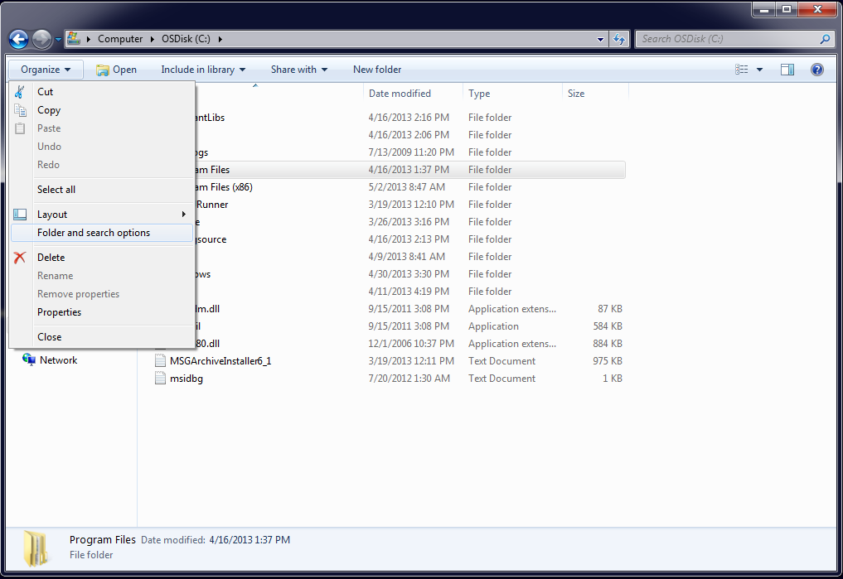

- Select the dialog’s View tab.
Figure 2: The Folder Options Dialog Box
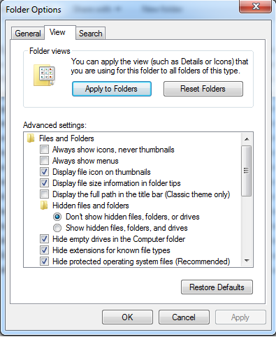.

- Click the Hidden files and folders folder.
- Select Show hidden files and folders.
- Click Apply to Folders in the Folder Views box.
- Windows displays the Folder views dialog box, which asks if you want to set all of the folders on your computer to match the current folder’s view settings.
- Click Yes.
- Click Apply.
- Click OK.

Configure new user account (testuser) for workstation’s Power, Sound, and Screensaver Settings
You’ll need to create a new user account to set up restrictions for system power, sound, and screensaver settings. When finished, copy the new user’s profile to the Default User Profile folder, after which you can delete the new user’s account if you want to.
Take the following steps on the machine that will power the site’s big-board display:
- Log in as a site or machine administrator. You must have local administrator rights to set the machine’s power schema.
- Click the Start Menu icon at the lower left corner of the Windows 7 task bar on your machine’s Desktop.
- Rick click the Computer item on the right side of the Start Menu and select manage.
- Expand the Local Users and Groups.
- Click to open the Users folder.
- Click Action on the dialog box’s main menu and select New User. The Windows system displays the New User dialog box, see figure below.
Figure 3 : The New User Dialog Box
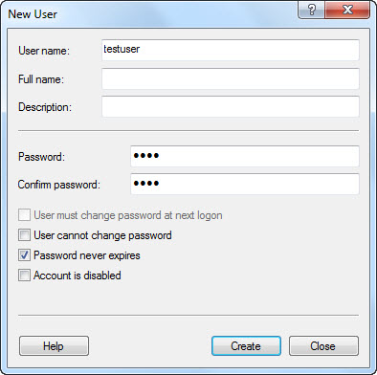

- Type testuser in the User name box.
- Type a password for the testuser account in the Password box.
- Type the same password in the Confirm password box.
- Cancel the selection of the User must change password at next logon box.
- Select the Password Never Expires box.
- Click Create.
- Click Groups in the left-hand pane.
- Double-click Administrators in the right-hand pane.
- Click Add. The Windows system displays the Select Users, Computers, or Groups dialog box. A Credential box will appear, click Cancel.
- Click Object Types and select the Users check box.
- Click Locations and select the computer’s name.
- Click OK.
- In the Enter the object names to select (examples) box, type testuser.
- Click OK. testuser should appear in the Members list.
- Click Apply.
- Log off the current administrator account.
- Log in using the newly created testuser account.

Change the Sound Control Setting to Mute (as testuser)
- Click the Volume icon in the Windows 7 taskbar at bottom right of screen.
- Select the Mute check box.
Figure 4: The Windows 7 Volume Control Tool
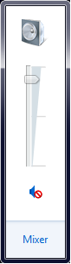

Configure Background, Screensaver and Power Settings (as testuser)
- Right-click anywhere on the Windows Desktop and select Personalize. Windows displays the Personalize dialog box (Figure 5).
- Select the Desktop Background icon at the bottom of the dialog.
- Under Picture Location select Solid Colors.
- Select the first blue color in the top row, then click Save Changes.
Figure 5: The Personalize Dialog Box
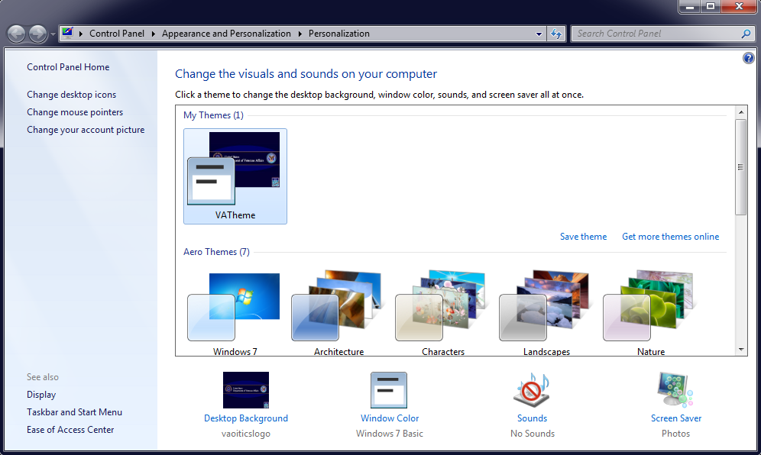

- Select the Screen Saver icon at the bottom of the dialog .
- Select (None) in the Screen Saver (Figure 6) drop-down list.
- Click Apply.
Figure 6: The Screen Saver dialog
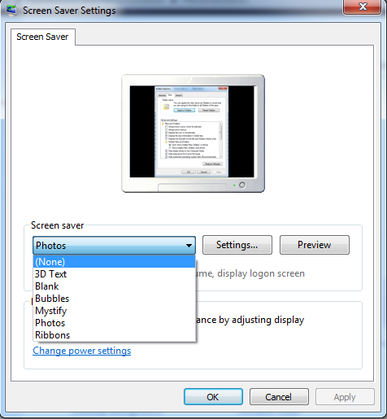

- Click the Start Menu icon at the lower left corner of the Windows 7 task bar on your machine’s Desktop.
- Click the Control Panel item on the right side of the Start Menu.
- In the Control Panel, click System and Security, then click Power Options (Figure 7).
Figure 7: Power Settings
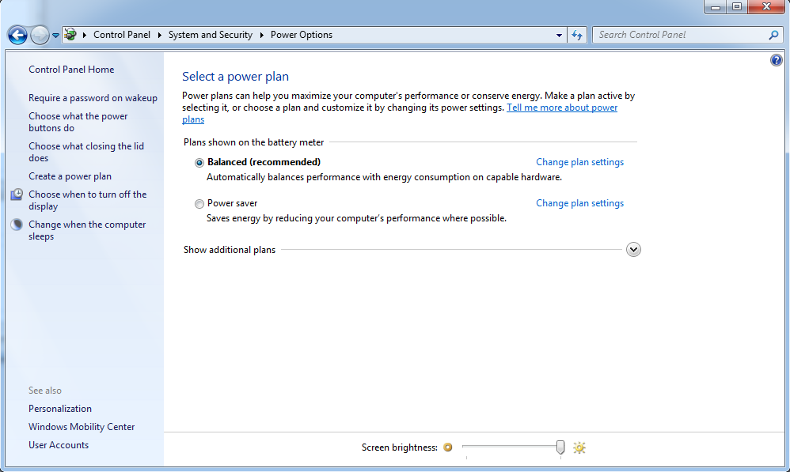

- The Balanced plan should be selected, click Change plan settings.
- In the Edit Plan Settings dialog, click Change advanced power settings.
- In the Power Options dialog, within the Advanced settings tab (Figure 8), ensure that all the following settings are set to Never or Disable : Hard disk, Sleep and Display.
- Click Apply.
- Click OK.
Figure 8: The Power Options Dialog Box, Advanced Settings tab
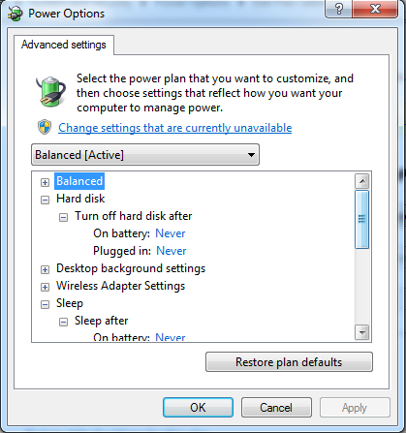

- Right-click anywhere on the Windows Desktop and select Screen resolution. Windows displays the Screen resolution dialog box.
- Select the best screen resolution for your monitor.
NOTE: Make note of the screen resolution you select. This information is needed to configure big-board display options in VistA. (Please see Section 5.1 for instructions on how to add a display-board size using the EDPF SCREEN SIZES parameter. For instructions on how to configure a display board’s screen size via the application’s Configure view, see the EDIS user guide’s “Add a New Display Board” section.)
- Click Apply.
- Click OK.

Copy the Testuser Profile Account into the Default User Account
- Log off the testuser account and log into the local administrator account.
- Using Windows Explorer, Go to C:\Users.
- Rename “Default” profile “Default Back”, see Figure 9.
Figure 9 : Windows Explorer, Renaming "Default" profile to "Default Back"
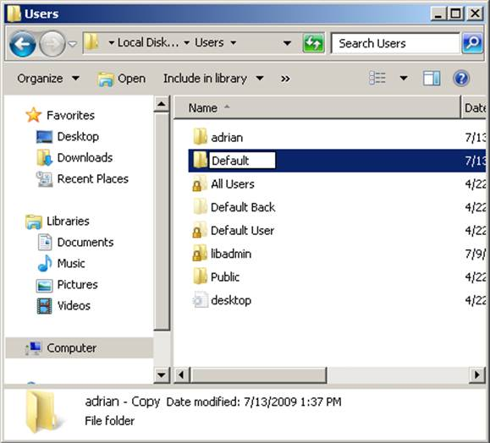

- Make a copy of “testuser” then rename the copy of “testuser”" (NOT THE ORIGINAL!!) to “Default”, see Figure 10.
Figure 10 : Windows Explorer, Renaming "testuser" to "Default"
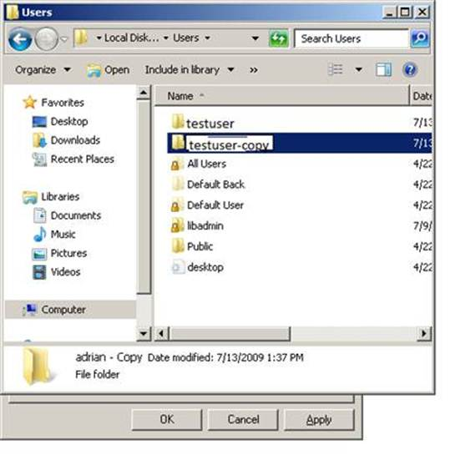

- Right-click on "Default" and set the permissions so that the "Everyone" and "Users" groups have "Read & Execute", "List Folder Content" and "Read" NTFS permissions (this may be set already by default), see Figure 11.
Figure 11 : Changing "Default" user permissions
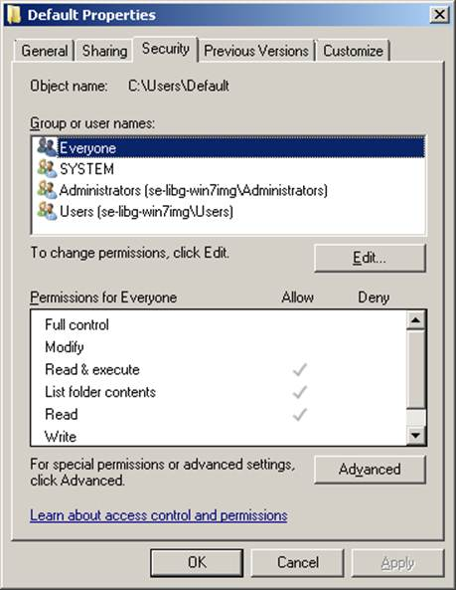

- Right-click Computer -> "Properties" -> "Advanced System Settings"->"User Profiles" and delete the "testuser" profile.
- Click OK.

Add Your Local IRM Security Group to the Machine’s Local Administrator Group.
You must add your local IRM security group to your computer’s Administrator group so that your local IRM staff can support the machine should something—a video card, for example—go awry.
- Click the Start Menu icon at the lower left corner of the Windows 7 task bar on your machine's Desktop.
- Right-click the Computer item on the right side of the Start Menu.
- Click on Manage.
- Windows displays the Computer Management dialog box.
- In the left-hand side of the pane, click to expand Local Users and Groups (under System Tools.)
- Click to open the Groups folder.
- Windows displays a list of the local machine’s groups in the right-hand pane.
- Double-click the Administrators group. Windows displays the Administrators Properties dialog box.
- Click the Add button.
- In the Enter the object names to select box, type
- <YOUR-LOCAL-DOMAIN>\ [YOURIRMSECURITYGROUPNAME].
- Click OK.

Configuring workstation

Add the User Service Account (VHAISLEDISBIGBOARD) to Its Own Local Administrator Group
You must add the display board to your computer’s Administrator group so that it will have access to the private keystores. A group policy will ensure that the display board remains locked down.
- Click the Start Menu icon at the lower left corner of the Windows 7 task bar on your machine's Desktop.
- Right-click the Computer item on the right side of the Start Menu.
- Click on Manage.
- Windows displays the Computer Management dialog box.
- In the left-hand side of the pane, click to expand Local Users and Groups (under System Tools.)
- Click to open the Groups folder.
- Windows displays a list of the local machine’s groups in the right-hand pane.
- Double-click the Administrators group. Windows displays the Administrators Properties dialog box.
- Click the Add button.
- In the Enter the object names to select box, type VHAMASTER\VHAISLEDISBIGBOARD.
- Click OK.
- Log out of the computer.
- Log in to the computer using :
- username : VHAISLEDISBIGBOARD
- password : B!gb0ard

Configure Auto Login and Auto Login Lockdown
On the computer that will power your big-board display, log in with local admin rights and do the following:
- If you haven’t already done this, retrieve the EDP2_1_1.zip file from an OFIO ANONYMOUS SOFTWARE directory. (See Section 2 above).
- Extract the contents of EDP_2_1_1.zip to a folder on your machine’s Desktop.
    - This folder will contain the following two files: Launch_EDIS.bat and edisautologon.reg.
- Open WordPad as Administrator, then open Launch_EDIS.bat.
- At the top of the file, locate the following lines and modify them as directed (see Figure 12 below for an example):
  - Set BoardValue=boardname -- Replace “boardname” with the board that has been configured through the EDIS application. Work with the EDIS Application Coordinator to review the configuration options for the display board.
NOTE: If the display board is set to Main (default), or if the display board is not defined, then the BoardValue should be blank.
  - Set SiteCodeValue=442 -- Replace “442” with your institution's number. This must be in the format 3 numbers and 2 letters (123ZZ) or 3 numbers (123).
  - Set UrlValue=http://vaemdapptst1.acc.va.gov:7010/bigboard/ -- Replace the URL with https://vaww.edisprod2.med.va.gov/bigboard/
NOTE: Make sure you include the trailing slash or the URL will not work.
Figure 12: Edit Settings in Launch_EDIS.bat
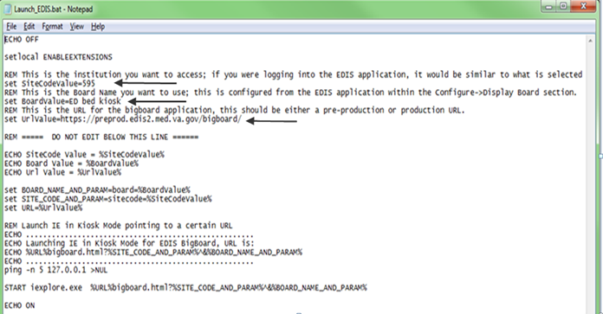
- Save Launch_EDIS.bat.
- Copy Launch_EDIS.bat to the following folder -- C:\Users\vhaisledisbigboard\AppData\Roaming\Microsoft\Windows\Start Menu\Programs\Startup
- The resulting directory path should look exactly like this C:\Users\vhaisledisbigboard\AppData\Roaming\Microsoft\Windows\Start Menu\Programs\Startup\Launch_EDIS.bat
- Next step is to run the edisautologon.reg file to make modifications to your registry. Double-click the edisautologon.reg file; this saves the registry settings that provide credentials for the EDIS auto-logon process to the machine’s registry files.
- Make sure the following message appears “The keys and values contained in edisautologon.reg have been successfully added to the registry”
- Click OK.
- Reboot the computer.
- Confirm that auto logon is working properly (the computer should automatically log in at this point).
- If the machine does not automatically log on, log on as an Administrator and repeat steps 8-11. Refer to section 6.3 for how to log into the machine as an Administrator if necessary.

Confirm your settings
After you have completed all the steps in the above sections, Verify you have:
- Configured the Display Board in the EDIS application for the correct resolution (Refer to User Guide)
- Verified your timeouts are configured to meet your needs (Refer to Section 6.2)
- Rebooted the computer/kiosk and checked to make sure:
- The EDIS big-board user auto logon is successful.
- The big-board screen kiosk mode executes properly.
If your machine has received the GPOs, it will automatically launch the big board. Otherwise, it will provide a relevant error message.
NOTE: This section provides instructions on how to change the national EDIS Oracle WebLogic Server your Big Board connects to by modifying the URL. This section should only be used when you need to modify your existing Big Board URL only. For new Big Board Installations, please follow the instructions in sections 3 and 4 above and skip this section.

Updating Big Board URL for EDIS v.2.1.2/EDP*2.0*2
Follow the steps below to update an existing EDIS system to work with EDIS v.2.1.2/EDP*2.0*2:
- Log on to the EDIS Big Board workstation as Local Administrator (see section 6.3 for instructions on how to log into the machine as an Administrator).
- Locate the Launch_EDIS.bat file. This file should have been saved locally during initial EDIS installation to this location: C:\Users\vhaisledisbigboard\AppData\Roaming\Microsoft\Windows\Start Menu\Programs\Startup\Launch_EDIS.bat
- Open WordPad as Administrator, then open Launch_EDIS.bat.
- At the top of the file, locate the following lines and verify them as directed (see Figure 13 below for an example):
  - Set BoardValue=boardname -- Verify “boardname” is set to the board that has been configured through the EDIS application. Work with the EDIS Application Coordinator to review configuration options for the display board.
NOTE: If the display board is set to Main (default), or if the display board is not defined, then the BoardValue should be blank.
  - Set SiteCodeValue=442 -- Verify “442” has been replaced with your institution's number. This must be in the format 3 numbers and 2 letters (123ZZ) or 3 numbers (123).
- At the top of the file, locate the following lines and modify them as directed (see Figure 13 below for an example):
  - Set UrlValue=http://vaemdapptst1.acc.va.gov:7010/bigboard/ -- Replace the URL with https://vaww.edisprod2.med.va.gov/bigboard/
NOTE: Make sure you include the trailing slash or the URL will not work. This URL has been updated with EDIS v.2.1.2/EDP*2.0*2.
Figure 13: Updating the EDIS URL in Launch_EDIS.bat
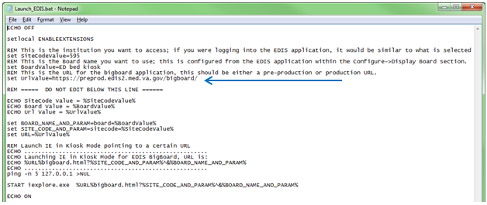
- Save Launch_EDIS.bat back to its original location, which should be: C:\Users\vhaisledisbigboard\AppData\Roaming\Microsoft\Windows\Start Menu\Programs\Startup\Launch_EDIS.bat
- Next step is to run the edisautologon.reg file to make modifications to your registry. Locate the edisautologon.reg file on your local machine. This file should be saved on the Desktop of the Testuser created from the original install or on the Local Administrator’s Desktop.
  - If you cannot locate the edisautologon.reg file that was saved locally during initial EDIS installation, it can be found within the EDP2_1_1.zip file on an ANONYMOUS directory (see Section 2 above). This folder will contain the following two files: Launch_EDIS.bat and edisautologon.reg.
  - Extract the contents of EDP_2_1_1.zip to a folder on your machine’s Desktop.
- Double-click the edisautologon.reg file; this saves the registry settings that provide credentials for the EDIS auto-logon process to the machine’s registry files.
- Make sure the following message appears “The keys and values contained in edisautologon.reg have been successfully added to the registry.”
- Click OK.
- Reboot the computer.
- Confirm that auto logon is working properly. The computer should automatically log on with VHAISLEDISBIGBOARD user and automatically open the EDIS Big Board.
- If the machine does not automatically log on, log on as an Administrator and repeat steps 7-11 (see section 6.3 for instructions on how to log into the machine as an Administrator).

Reference

Adding a new Display Board Size for EDIS
The EDIS Configure view allows users to select the optimal screen size for your site’s electronic whiteboard (or big-board) display. The application ships with the following predefined display sizes:
- 640 x 480
- 800 x 600
- 1024 x 768
- 1280 x 800
- 1280 x 1024
If your site’s optimal display size is not on this list, you can add it by taking the following steps.
  - Log in to VistA.
  - At the Select OPTION NAME prompt, type xpar menu (for XPAR MENU TOOLS) and then press the <Enter> key.
  - At the Select General Parameter Tools Option prompt, type ep (for Edit Parameter Values) and then press the <Enter> key.
  - At the Select PARAMETER DEFINITION NAME prompt, type edpf screen (for EDPF SCREEN SIZES) and then press the <Enter> key.
  - At the Enter selection prompt, type 5 (for Division) and then press the <Enter> key.
  - At the Select INSTITUTION NAME prompt, type the name of your institution or its station number and then press the <Enter> key.
  - At the Select Sequence prompt, type a number that represents the selection-list sequence in which you want the display size to appear and press the <Enter> key.
  - If you are adding this sequence as a new sequence, respond to the Are you adding…as a new Sequence? Yes// prompt by pressing the <Enter> key to accept the default.
  - At the Screen Size (WIDTHxHEIGHT) prompt, type the screen size you want EDIS to list and press the <Enter> key.
  - Repeat steps 7 through 9 to add additional selections to the screen-size list (as needed).

Configure EDIS Timeouts and Timeout Countdowns
EDIS uses the following parameter settings for application timeouts and timeout countdowns:
- EDP APP TIMEOUT and EDP APP COUNTDOWN settings.
  - If the EDP APP TIMEOUT parameter contains a value, this value determines the amount of time that EDIS can sit idle before it displays a timeout warning and begins its countdown.
  - If the EDP APP TIMEOUT parameter contains no value, EDIS uses the value of the Timed Read (DTIME) parameter, which is available through VistA’s user-setup menu.
NOTE: The value of the EDP APP COUNTDOWN setting determines the length of the EDIS application’s timeout countdown.
NOTE: EDIS displays its timeout message and countdown within the browser, at the bottom of users’ current EDIS views.
NOTE: Because JAWS cannot read this message, EDIS also sounds a chime as it begins its timeout countdown.

Set the EDIS Timeout
- Log in to VistA.
- In XPAR MENU TOOLS, at the Select General Parameter Tools Option prompt, type EP (Edit Parameter Values) and press the <Enter> key.
- At the Select PARAMETER DEFINITION NAME prompt, type EDP APP TIMEOUT and press the <Enter> key.
- At the Enter selection prompt, type the number 1 (User), 3 (Division), or 5 (System), depending upon the level at which you want to apply this timeout value.
    - If you typed the number 1 (User), type the user’s name at the Select NEW PERSON NAME prompt.
    - If you typed the number 2 (Division), type the division or institution name at the Select INSTITUTION NAME prompt.
- At the Timeout (GUI Chart) prompt, type the number of seconds that can pass with EDIS idle before the chart or EDIS times out.
NOTE: The longest number of seconds that will currently work for EDIS timeout values is 999999 (about 11.5 days).
NOTE: You can set the EDP APP TIMEOUT parameter at the system, division, and user levels.

Log in to the Kiosk as an Administrator
If you find it necessary to stop the auto logon process and log in to the machine as an administrator:
- Simultaneously press the <Ctrl>, <Alt>, and <Delete> keys while the big board kiosk screen is running.
- Click the Logoff button to log off the EDIS big-board user.
- When you see the VA security banner, do not click on the OK button. Instead, hold down the <Shift> key and press the <Enter> key. This will bring up the Windows login dialog box.
- Use this dialog box to log in to the machine as an administrator
NOTE: You can also stop the auto logon process when the VA Security banner screen appears. Instead of clicking OK, simultaneously press the <Shift> and <Enter> keys. This will stop the auto logon process and allow you to log in as an administrator.

Troubleshooting

If you have any problems or questions please open a Remedy Ticket and the Product Support Team will assist you with your install.

How to Configure Registry Setting
The method is to log onto the machine as an administrator and change the registry setting for the user vhaisledisbigboard. Below are instructions to help locate the vhaisledisbigboard user’s SID (Security IDentifier) and the registry key holding the screen saver on/off switch.
NOTE: Please do not attempt this unless you are comfortable using the Windows Registry editor, and it is highly recommended to back up your registry first. You may want to consider seeking assistance from a Systems Administrator if you chose to attempt this.
- Break out of the kiosk machine lock-down mode as described in Section 6.3
- When logging on as a local machine administrator, change the domain prompt from VHAMASTER to the name of your machine.
- Find the SID for the user “vhaisledisbigboard”:
  - Open the registry editor
  - Go to the key:
HKEY_LOCAL_MACHINE\SOFTWARE\Microsoft\Windows NT\CurrentVersion\ProfileList
  - Expand the ProfileList key and you will see a folder for each user. You can ignore the short ones (e.g. S-1-5-18). Starting at the long ones, select each one in turn and look the value in ProfileImagePath. It will be something like “%SystemDrive%\Users\<User_ID>”.
  - Find the one which has the user ID “vhaisledisbigboard”
(%SystemDrive%\Users\vhaisledisbigboard)
  - Make a note of the SID (last digits after the final dash will probably suffice, this is only to recognize the correct SID.
- Locate the vhaisledisbigboard user’s screen saver settings:
(Still in the Registry Editor):
  - Go to the HKEY_USERS root
  - Select the Key for the SID you just located in the previous step.
  - Drill down to C:\Desktop
  - Within the Desktop key scroll down to “ScreenSaverActive”. If the value is “1” then the screen saver is active. If this is the case, double-click the parameter name “ScreenSaverActive” and change the value to “0” (zero – without the quotes).
  - Exit the registry editor.

Applying or Re-applying GPO Settings
To force GPO settings to be reapplied to the workstation run the following command from a DOS prompt of the workstation:
C :> gpupdate /force
There should be two GPOs pushed to the workstation, Auto-enrollment and Lockdown.
If you are having issues with the GPOs being applied, please open a Remedy ticket requesting support in the following areas for the GPOs.
- Creating Remedy Ticket
  - Select the Display Board Setup Request option. This is under the:
Category – Applications-VistA
Type - Emergency Department Integration Software
Item – Redeploy the GPOs for the EDIS Display Board

Acronyms
Acronym | Definition
CPRS | Computerized Patient System Records
ED | Emergency Department
EDIS | Emergency Department Integration Software
EDP | Namespace for EDIS
GUI | Graphical User Interface
GPO | Group Policy Objects
IE | Internet Explorer
IRM | Information Resource Management
JAWS | Job Access with Speech
KIDS | Kernel Installation and Distribution System
LCD | Liquid Crystal Display
VA | Veterans Affairs
URL | Uniform Resource Locator
VAMC | Veterans Affairs Medical Center
VISN | Veterans Integrated Services Network
VistA | Veterans Health Information Systems and Technology Architecture
VDL | VistA Documentation Library

